Set-06

Agile lab fat
Yuvasri.p
23MIS0262
EXPENSE TRACKING SYSTEM

Solution:
Git.
*create new repository and enable readme .
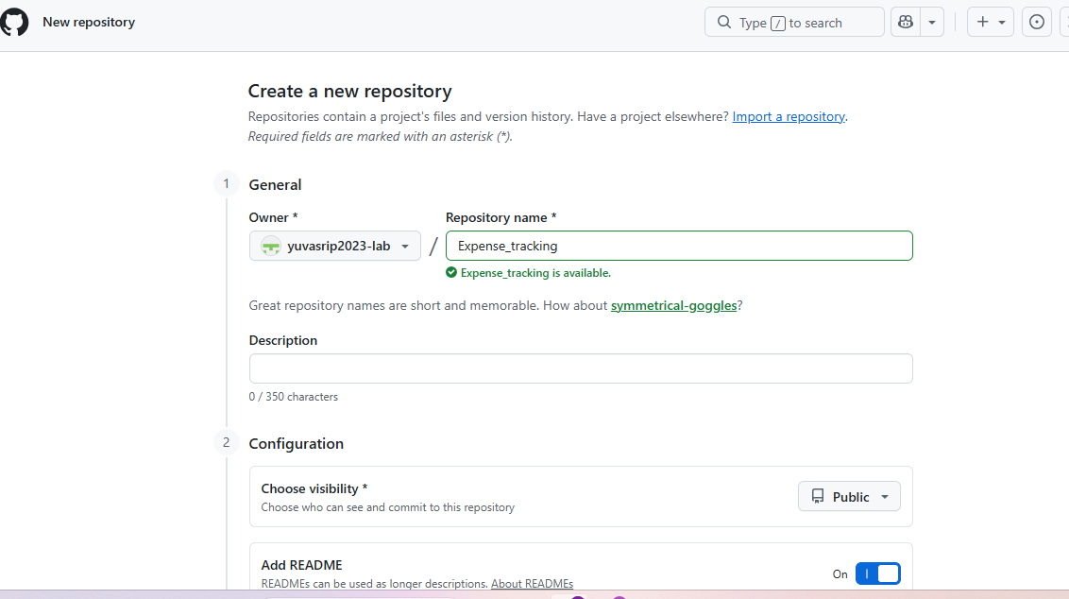
Create and add new file in that repository.
Create pom.xml
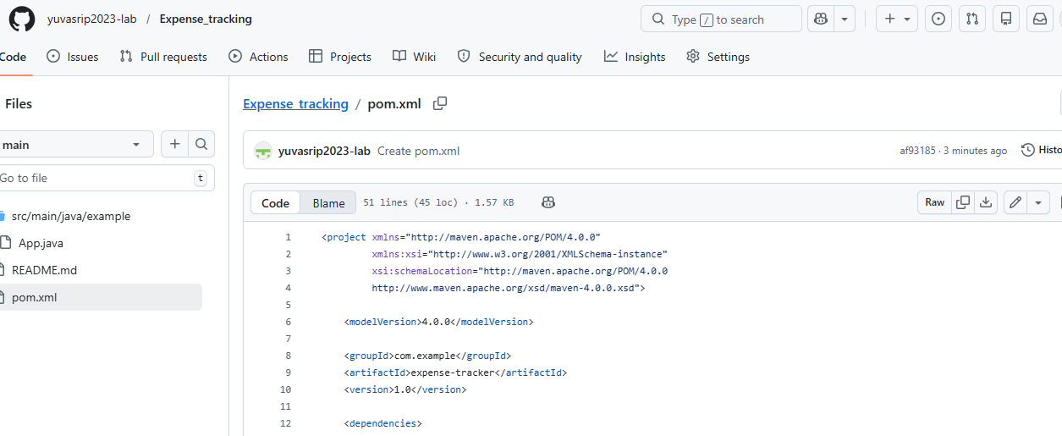
Create app.java
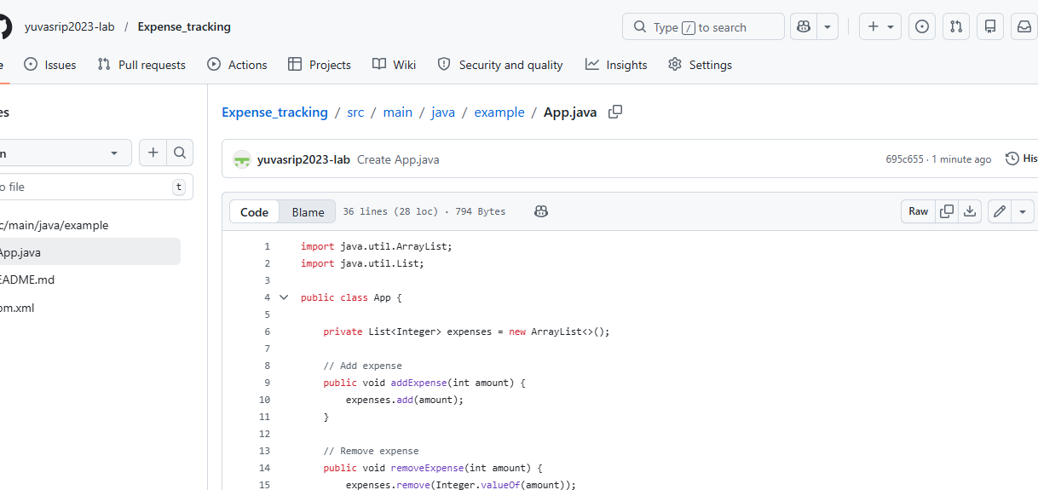
Create apptest.java
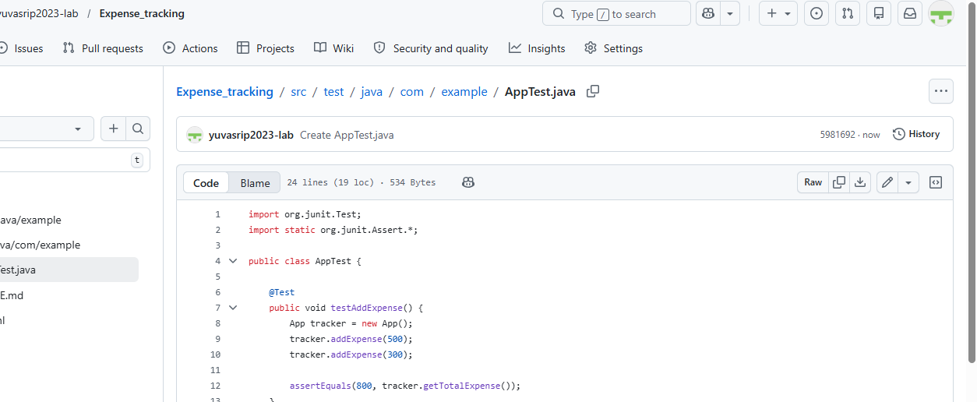

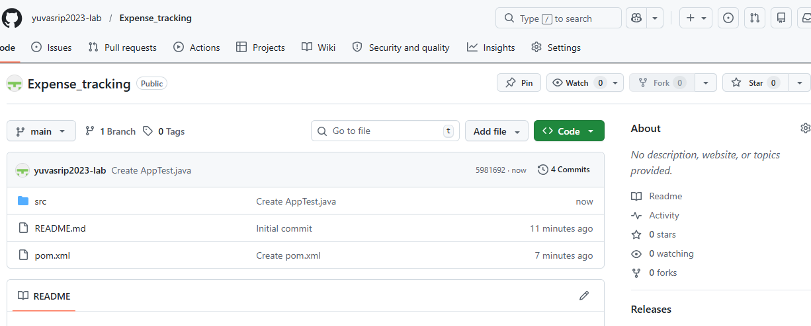

02) visual git push and clone
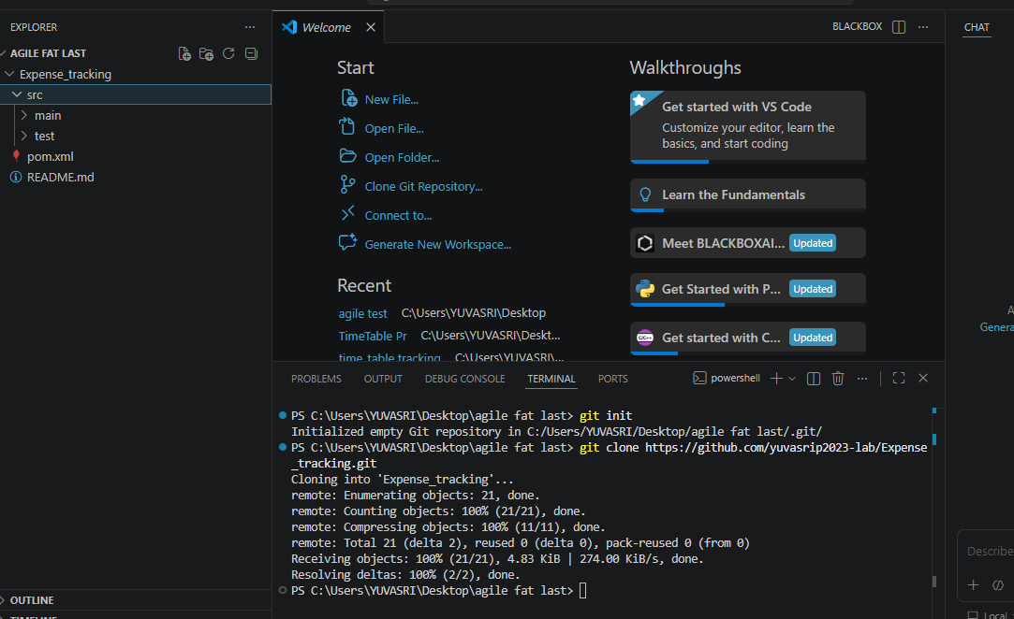
Successfully git push and clone.
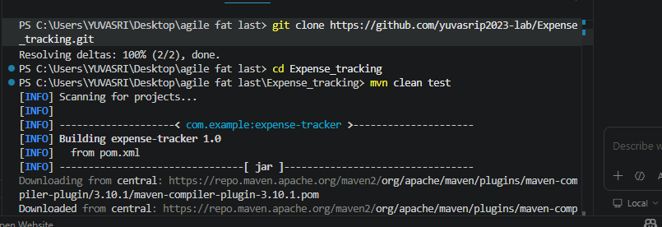
Done mvn clean test
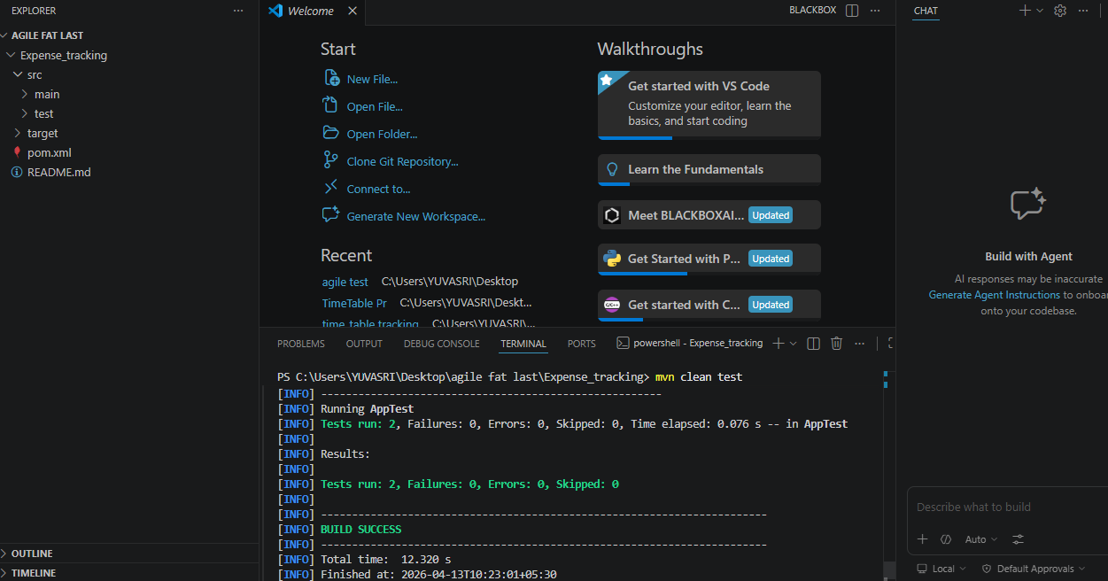
Build sucesss.
03) jenkin
Create pipeline
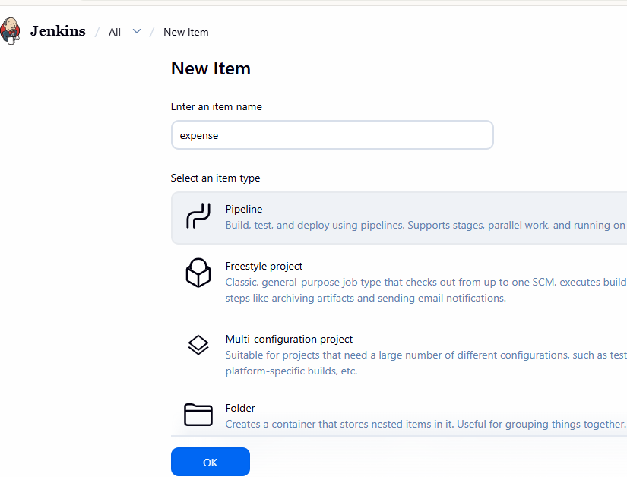
Click ok
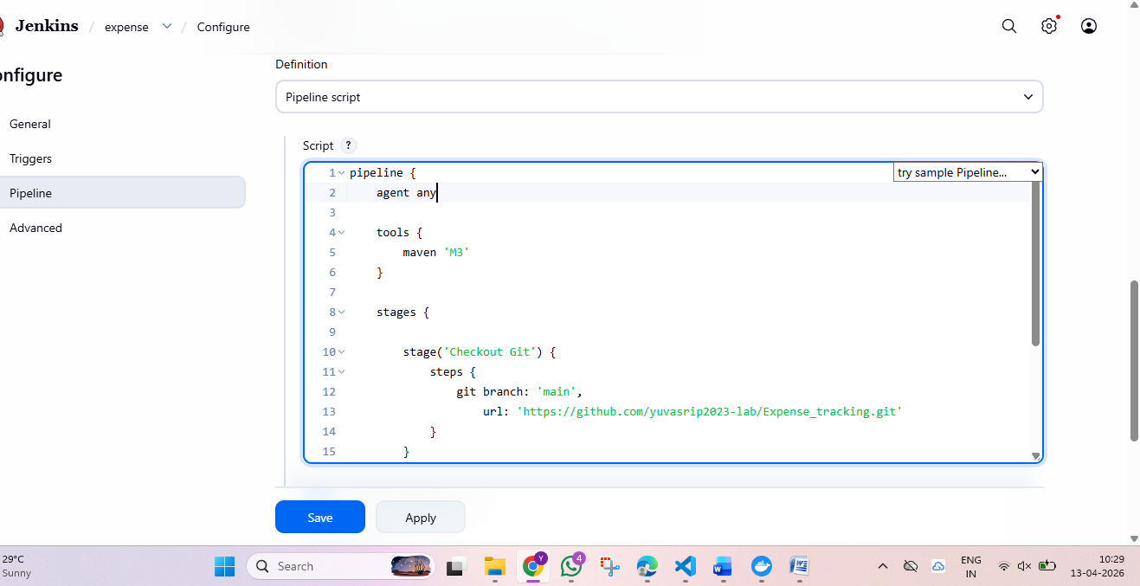
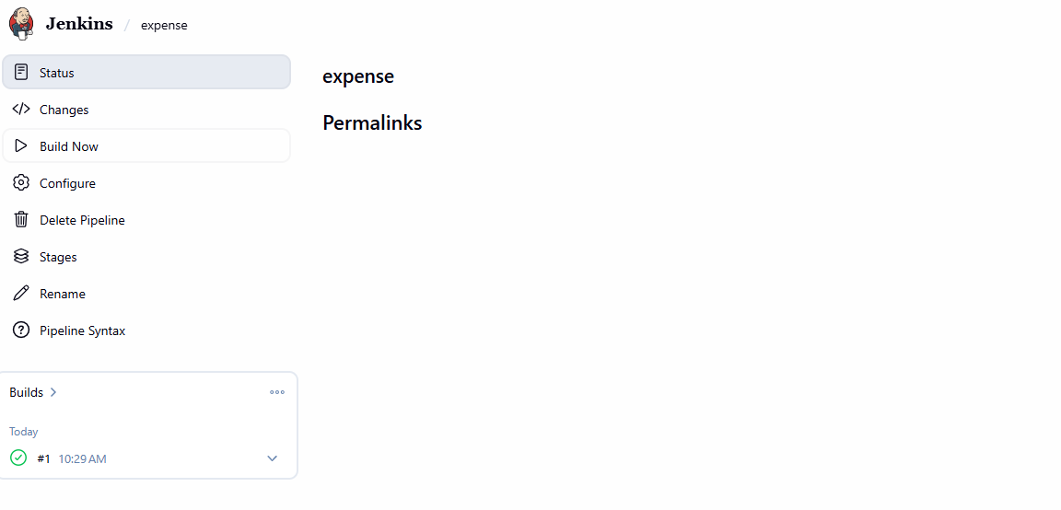
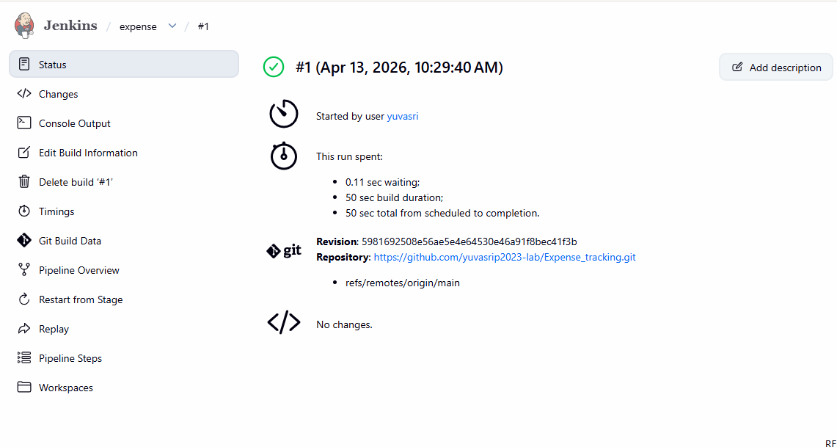
Ci/cd pipeline run sucesss
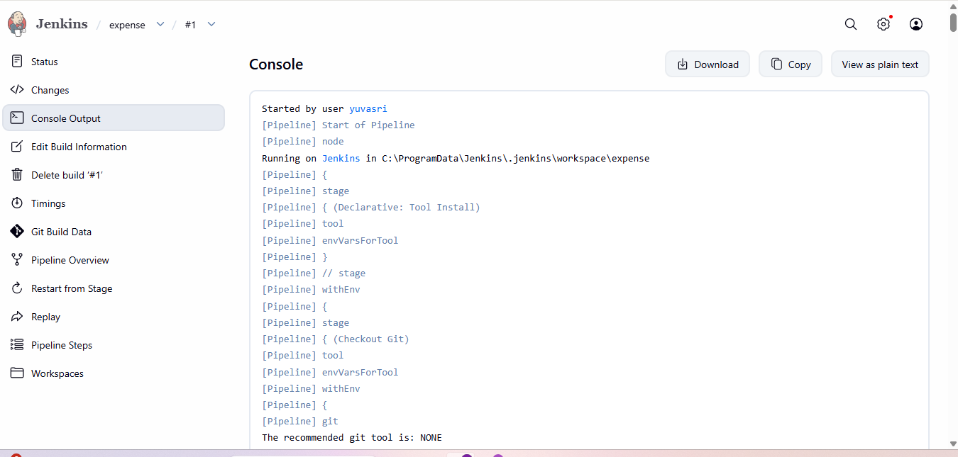
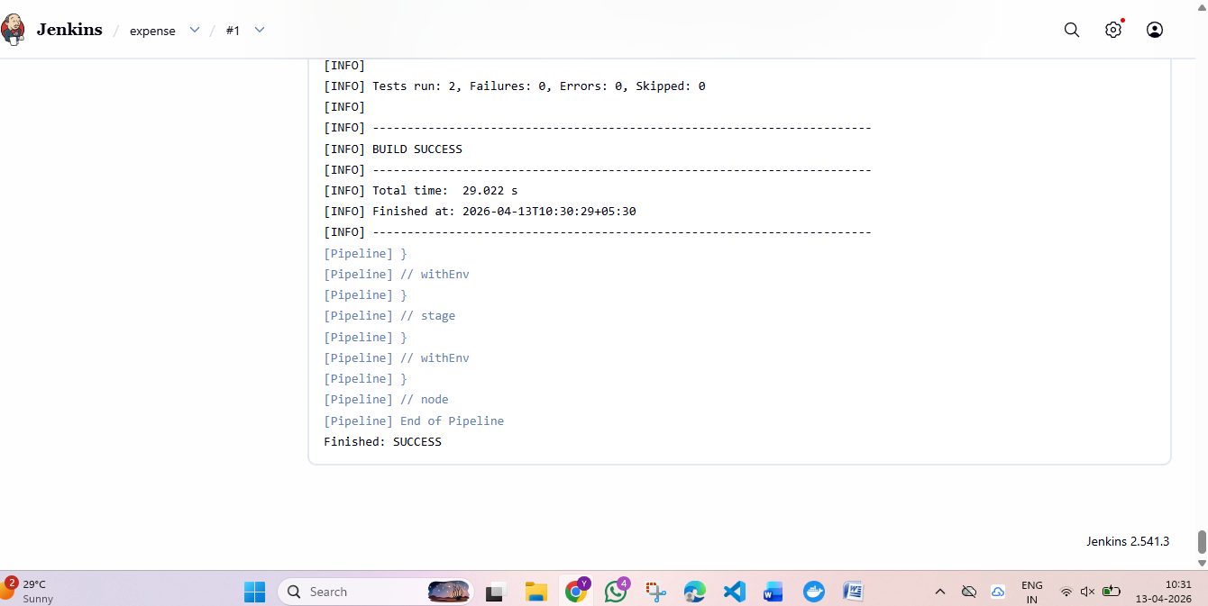

04) docker
Enable the kubernets in docker.
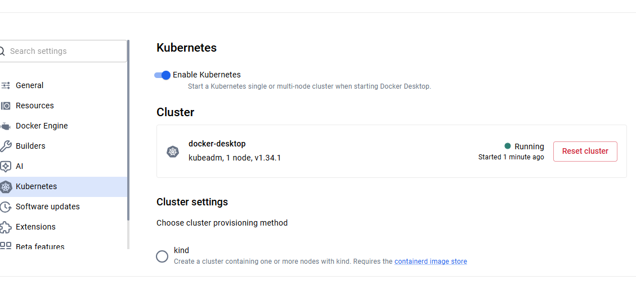
Create docker file and deployment.yaml file
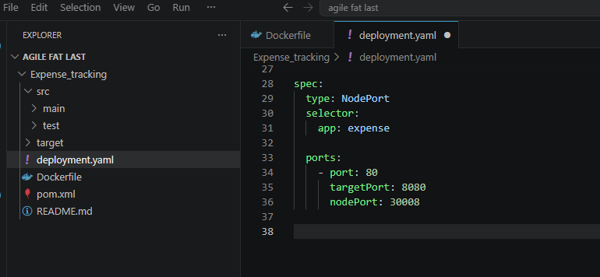
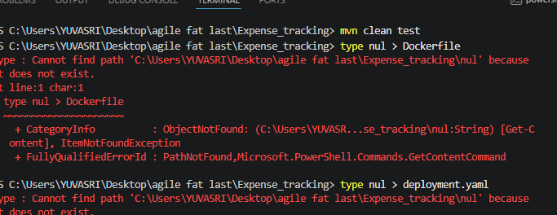
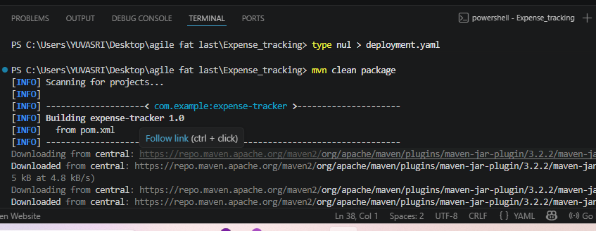
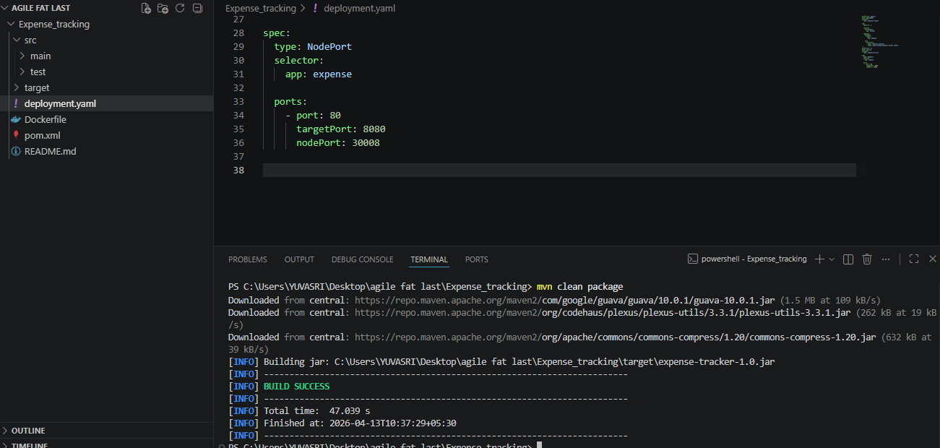
Mvn clean package success.
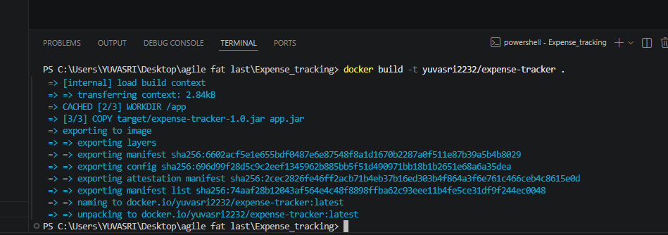
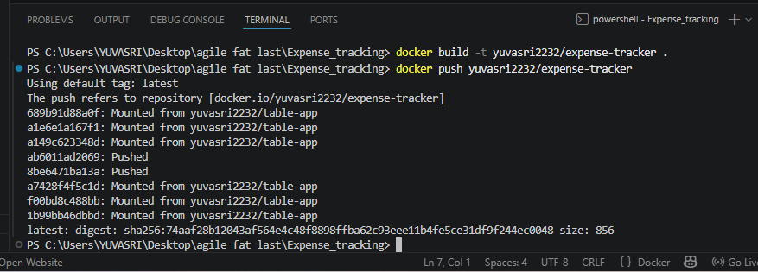
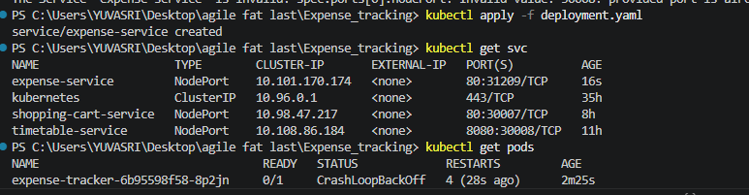
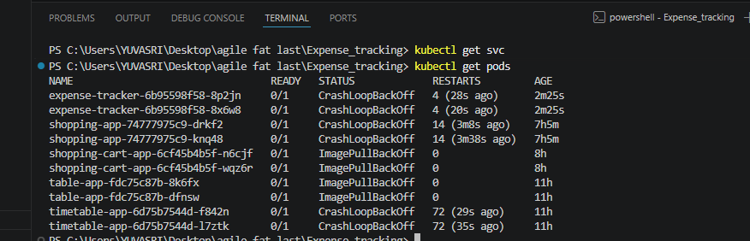

In kubernets pods
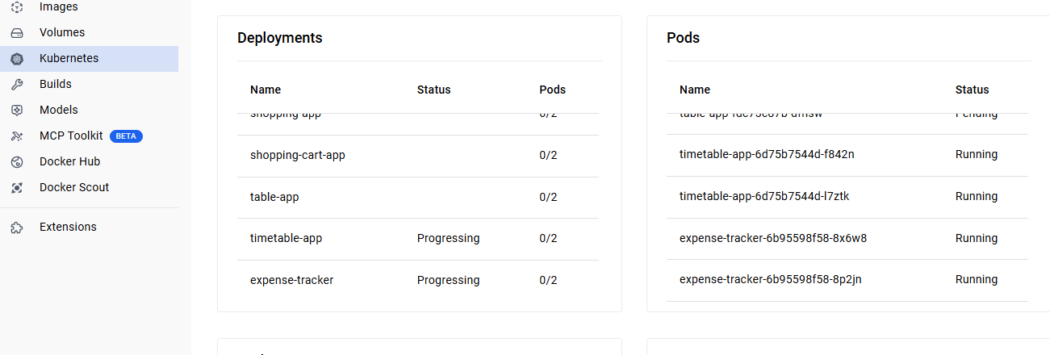
Docker.
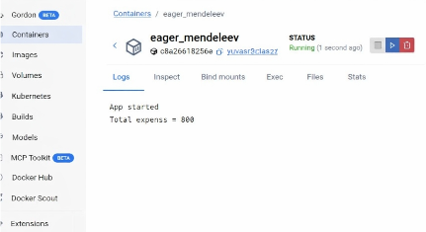

POM.XML
<project xmlns="http://maven.apache.org/POM/4.0.0"
xmlns:xsi="http://www.w3.org/2001/XMLSchema-instance"
xsi:schemaLocation="http://maven.apache.org/POM/4.0.0
http://www.maven.apache.org/xsd/maven-4.0.0.xsd">

<modelVersion>4.0.0</modelVersion>

<groupId>com.example</groupId>
<artifactId>expense-tracker</artifactId>
<version>1.0</version>

<dependencies>
<!-- JUnit -->
<dependency>
<groupId>junit</groupId>
<artifactId>junit</artifactId>
<version>4.13.2</version>
<scope>test</scope>
</dependency>
</dependencies>

<build>
<plugins>
<!-- Java version -->
<plugin>
<groupId>org.apache.maven.plugins</groupId>
<artifactId>maven-compiler-plugin</artifactId>
<version>3.10.1</version>
<configuration>
<source>17</source>
<target>17</target>
</configuration>
</plugin>

<!-- Main class -->
<plugin>
<groupId>org.apache.maven.plugins</groupId>
<artifactId>maven-jar-plugin</artifactId>
<version>3.2.2</version>
<configuration>
<archive>
<manifest>
<mainClass>com.example.App</mainClass>
</manifest>
</archive>
</configuration>
</plugin>
</plugins>
</build>

</project>

APP.JAVA
import java.util.ArrayList;
import java.util.List;

public class App {

private List<Integer> expenses = new ArrayList<>();

// Add expense
public void addExpense(int amount) {
expenses.add(amount);
}

// Remove expense
public void removeExpense(int amount) {
expenses.remove(Integer.valueOf(amount));
}

// Calculate total expense
public int getTotalExpense() {
int total = 0;
for (int expense : expenses) {
total += expense;
}
return total;
}

// Main method
public static void main(String[] args) {
App tracker = new App();
tracker.addExpense(500);
tracker.addExpense(300);

System.out.println("Total Expense: " + tracker.getTotalExpense());
}
}

APPTEST.JAVA
import org.junit.Test;
import static org.junit.Assert.*;

public class AppTest {

@Test
public void testAddExpense() {
App tracker = new App();
tracker.addExpense(500);
tracker.addExpense(300);

assertEquals(800, tracker.getTotalExpense());
}

@Test
public void testRemoveExpense() {
App tracker = new App();
tracker.addExpense(500);
tracker.addExpense(300);
tracker.removeExpense(300);

assertEquals(500, tracker.getTotalExpense());
}
}

DOCKER.
FROM eclipse-temurin:17-jdk
WORKDIR /app
COPY target/*.jar app.jar
CMD ["java", "-jar", "app.jar"]
DEPLYEMENT.YAML
apiVersion: v1
kind: Service
metadata:
name: expense-service

spec:
type: NodePort
selector:
app: expense

ports:
- port: 80
targetPort: 8081

